Task 1

#include<iostream>

using namespace std;

main()

{

int arr[10];

//int arr[10] = {5,1,3,6,2,9,7,4,8,10};

for(int i=0;i<10;i++)

{

cout<<"Enter the value: ",cin>>arr[i];

}

int temp;

for(int i=0;i<10;i++)

{

for(int j=0;j<10;j++)

{

if(arr[i]<arr[j])

{

temp=arr[i];

arr[i]=arr[j];

arr[j]=temp;

}

}

}

for(int i=0;i<10;i++)

{

cout<<arr[i]<<" ";

}

}

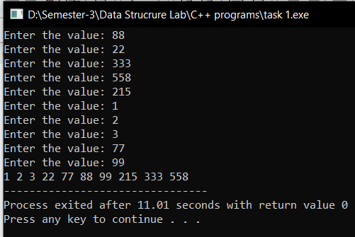

Task 2

#include<iostream>

struct Date{

int date;

int month;

int year;

};

using namespace std;

int main(){

// e1.year = 23;

// e2.year = 22;

// e3.year = 20;

// e3.year = 24;

// e3.year = 21;

// Date d[5] = {{23, 07, 2021},{23, 07, 2022},{23, 07, 2025},{23, 07, 2023},{23, 07, 2020} };

Date d[5];

int i, j, smallest,temp;

int n = 5;

// cout<<"Enter the date" << "\n";

for(i=0;i<n;i++){

// cout << d[i].date <<"/" <<d[i].month <<"/"<<d[i].year<<"\n";

cout<<"Enter the date "<<i+1 <<"\n";

cin>>d[i].date ;

cin>>d[i].month;

cin >> d[i].year;

}

for(j=0;j<n-1;j++){

smallest = j;

for(i=j+1;i<n;i++){

if(d[i].year<d[smallest].year){

smallest = i;

}

}

swap(d[j],d[smallest]);

}

for(i=0;i<n;i++){

cout << d[i].date <<"/" <<d[i].month <<"/"<<d[i].year<<"\n";

}

}

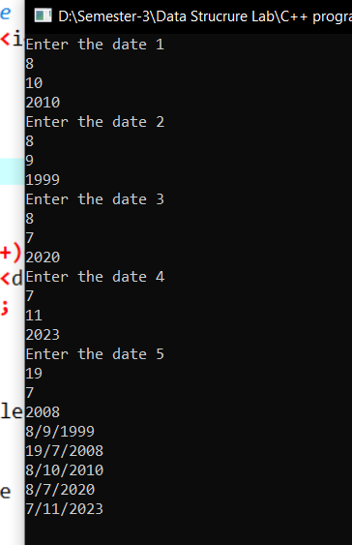

Task 3

#include<iostream>

#include<string>

using namespace std;

struct Member{

string post;

int num;

};

int main(){

Member member[] ={{"EMP",6},{"CFO",3},{"MGR",5},{"EMP",6},{"VP",4},{"CTO",2},{"MGR",5},{"CEO",1}};

int i , j;

int n= 8;

for(i=1;i<n;i++){

Member sm = member[i];

int j=i-1;

while(j>= 0 &&member[j].num>sm.num){

member[j+1] = member[j];

j=j-1;

}

member[j+1]=sm;

}

cout<<"Sorted Array is"<<endl;

for(i=0;i<n;i++){

cout<<member[i].post<<endl;

}

}

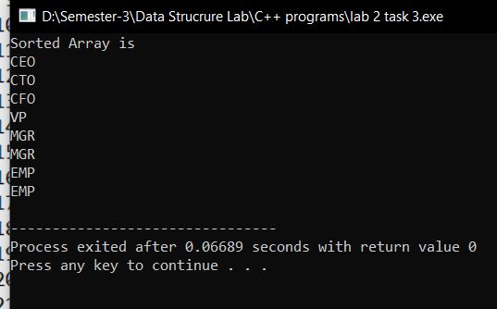

Task 4

#include<iostream>

using namespace std;

// We will use the insertion sort as it first compare the all array then it shift the pasition

int main(){

// Assuming the in hours hours

// cout<<"Hello";

//int time[10] = {3,5,8,1,7,6,9,2,13,4};

int num;

cout<<"Enter the size of array: ",cin>>num;

int time[num];

cout<<"Enter the array: "<<endl;

for(int i=0;i<num;i++)

{

cin>>time[i];

}

int i,j;

for(i=0;i<num;i++){

int key = time[i];

j=i-1;

while(j>=0&&key<time[j]){

time[j+1]= time[j];

j=j-1;

}

time[j+1]=key;

}

cout<<"Sorted Array is "<<endl;

for(i=0;i<num;i++){

cout<<time[i]<<endl;

}

}

